# ABOUT US

We’re Albin, Adithya and Nasnida— three minds driven by a shared passion for robotics, innovation, and purposeful problem-solving. United by curiosity and a commitment to growth, we’ve spent years honing our skills from designing efficient systems to building resilient bots and crafting smart strategies.Every challenge we face is a chance to grow not just as individuals, but as a team.Every project we take on is an opportunity to push boundaries, learn deeply, and build something that lasts.For us, robotics isn’t just a field it’s a mindset. WRO is more than a competition; it’s the next step in our journey to learn, lead, and make an impact.

### Our Team

Albin Binu K is currently pursuing a BCA and is always looking for ways to apply what he learns in real-world projects. He enjoys taking initiative, learning beyond the classroom, and is more interested in exploring startup ideas than committing to a long-term company job.

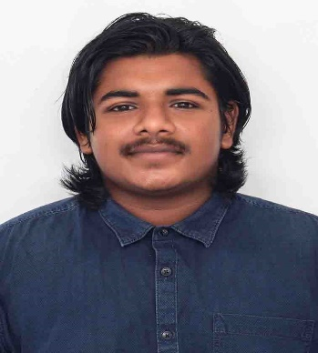

Adithya Sree Sivaramanand is a passionate BCA student with a strong interest in AI, robotics, and electronics. He enjoys building smart solutions, exploring emerging technologies, and is always ready to tinker often with a screwdriver in hand.

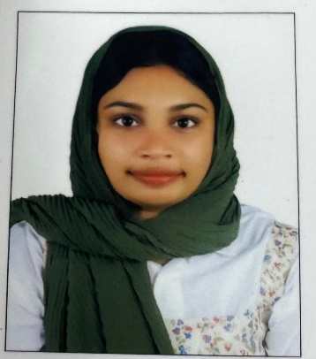Nasnida A N is a BCA student with a strong interest in software development and emerging technologies. She enjoys building creative solutions to real-world problems and actively explores new tools and concepts beyond the classroom. With a passion for continuous learning, she aims to grow as an innovative and skilled developer FLL teams while exploring real-world tech solutions.